# LAB # 15

**Objective: Assemble two input AND gates with the help of discrete components and verify their logic operation.**

**Equipment:**

**IC 7408**

* + Logic probe
  + Breadboard
  + 5V DC Power Supply or Battery
  + Connecting Wires

**Theory:**

An AND gate is a basic logic gate that outputs HIGH (1) when both of its inputs are HIGH (1). The logic expression for AND gate is:

### C = A. B

The truth table for a two-input AND gate is:

|  |  |  |
| --- | --- | --- |
| **INPUT A** | **INPUT B** | **OUTPUT C** |
| 0 | 0 | 0 |
| 0 | 1 | 0 |
| 1 | 0 | 0 |
| 1 | 1 | 1 |

**Procedure:**

* + Determine pins of transistors according to their datasheet.
  + Place both transistors on a breadboard.
  + Assemble the circuit on the breadboard according to the circuit diagram.
  + Verify the results against the AND gate truth table by setting input values.

**Truth Table Verification:**

|  |  |  |
| --- | --- | --- |
| **INPUT A** | **INPUT B** | **LED OUTPUT** |
| 0 | 0 | OFF |
| 0 | 1 | OFF |
| 1 | 0 | OFF |
| 1 | 1 | ON |

**Conclusion:**

The two-input AND gate was successfully assembled using discrete components, and the operation was verified by matching the output with the expected truth table.

**Circuit Diagram:**

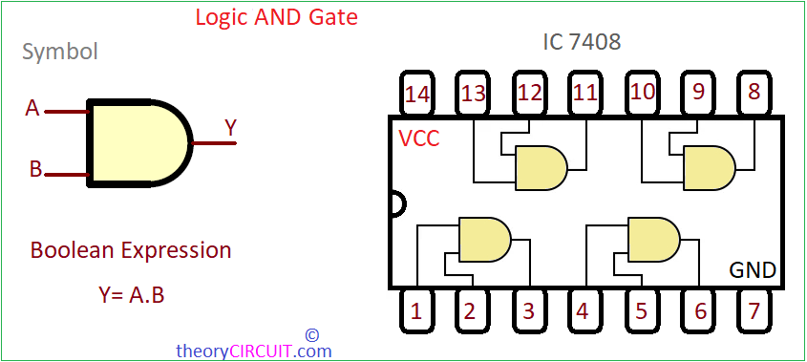

**POST LAB:**

1. How does the operation of the AND gate with transistors differ from its implementation using diodes?
2. What would happen if one of the transistors was faulty or incorrectly wired?
3. What will be the output of an AND gate if both of its inputs are at logic low?